FOUNDATIONS OF ARTIFICIAL INTELLIGENCE
AI-POWERED CROP DISEASE DETECTION
AND TREATMENT RECOMMENDATION

A PROJECT REPORT
Submitted by
SHARUKESH D - 240701490
SADHOK S - 240701450
III YEAR
COMPUTER SCIENCE AND ENGINEERING
DEPARTMENT OF COMPUTER SCIENCE AND ENGINEERING
RAJALAKSHMI ENGINEERING COLLEGE
THANDALAM, CHENNAI – 602 105

OCTOBER 2026

BONAFIDE CERTIFICATE
Certified that the project titled “AI-Powered Crop Disease Detection and Treatment Recommendation System using A* Algorithm” is the bonafide work carried out by [STUDENT NAME 1] and [STUDENT NAME 2] under the guidance of [FACULTY NAME], in partial fulfilment of the requirements of the course Foundations of Artificial Intelligence.
The project presents a working web-based application implemented using Python, Flask, HTML, CSS and JavaScript. It identifies crop diseases from leaf images using a convolutional neural network and applies the A* search algorithm to recommend a minimum-cost treatment plan. Experimental measurements and final screenshots must be inserted only after validation against the working application.
SIGNATURE OF THE FACULTY INCHARGE

Submitted for the Practical Examination held on: ____________________

SIGNATURE OF THE INTERNAL EXAMINER

TABLE OF CONTENTS
NO. TITLE PAGE NO.
ABSTRACT 04
LIST OF TABLES 05
LIST OF FIGURES 06
LIST OF SYMBOLS AND ABBREVIATIONS 07
1 INTRODUCTION 08
2 LITERATURE REVIEW 10
3 DOMAIN AREA AND BACKGROUND 12
4 PROBLEM FORMULATION 14
5 PROPOSED SYSTEM 18
6 SYSTEM ARCHITECTURE AND DESIGN 23
7 ALGORITHMS 27
8 IMPLEMENTATION DETAILS 33
9 TESTING AND VALIDATION 38
10 EXPERIMENTAL EVALUATION 41
11 RESULTS AND DISCUSSION 44
12 LIMITATIONS AND RISK ANALYSIS 47
13 FUTURE WORK 50
14 LEARNING OUTCOMES 52
15 CONCLUSION 53
16 ACKNOWLEDGEMENT 54
17 REFERENCES 55

ABSTRACT
Crop diseases cause large losses in yield and quality, and early identification followed by the right treatment decision is critical for protecting a harvest. Many farmers have limited access to plant pathologists and often rely on visual inspection or informal advice. This project, AI-Powered Crop Disease Detection and Treatment Recommendation System using A* Algorithm, presents a working web-based application that connects image-based diagnosis with search-based treatment planning.
A convolutional neural network built with transfer learning classifies a leaf photograph into a crop-disease class and returns a confidence value. If the confidence is below a configured threshold, the system asks for a clearer image instead of guessing. Otherwise a severity estimator converts the visible lesion area into one of four discrete severity levels. The treatment decision is then modelled as a state-space search problem in which a state records the current severity and the set of treatments already used, actions are treatments from a knowledge base, and the cost of an action combines monetary cost, toxicity, waiting interval and resistance risk. The A* algorithm searches this space with a heuristic equal to the cheapest cost per unit of severity reduction multiplied by the current severity. This heuristic is shown to be admissible and consistent, so the planner returns the minimum-cost plan within the encoded model.
The application is developed with Python and Flask for server-side processing and with HTML, CSS and JavaScript for the user interface. Public or synthetic data is used for development. Quantitative measurements of classifier accuracy and planner performance have not yet been collected; therefore this report documents a repeatable evaluation procedure and leaves results as clearly marked placeholders until real runs are completed. The project demonstrates the practical combination of deep learning and classical heuristic search, distinguishes model-relative optimality from real-world suitability, and acknowledges that its recommendations must be reviewed by a qualified agronomist.
Keywords — crop disease detection, convolutional neural network, transfer learning, A* search, admissible heuristic, treatment recommendation, state-space search, Flask.

LIST OF TABLES
Table No. Title Page No.
1 Examples of crop-disease classes and typical visual cues 12
2 Notation used in the formulation 14
3 Components of the action cost 15
4 Hard constraints and verification status 16
5 Functional requirements 19
6 Non-functional requirements 20
7 Conceptual API routes (to be reconciled with the source code) 24
8 Illustrative structure of knowledge-base entries (model parameters, not agronomic advice) 28
9 A* trace for the worked example 30
10 Qualitative comparison of methods for treatment planning 31
11 Planner and classifier parameters to be recorded 31
12 Technology stack (reference; verify names and versions against the project) 33
13 Dataset description template 33
14 Training configuration to be recorded 34
15 Test case summary (statuses to be filled after execution) 38
16 Planner configurations compared 41
17 Classifier results template 42
18 Planner results template 42
19 Risk analysis register 47

LIST OF FIGURES
Figure No. Title Page No.
1 Execution workflow of the proposed system 19
2 Layered architecture of the proposed system 23
3 Conceptual data model of the application 25
4 Transfer-learning classifier pipeline 27
5 Illustrative disease-to-treatment graph of the knowledge base 28
6 A* search tree for the worked example (severity 3) 30
7 Application dashboard (home page) 35
8 Disease diagnosis result with confidence 35
9 Treatment plan generated by the A* planner 35
10 Low-confidence message and diagnosis history 36
11 Confusion matrix of the classifier on the test set 44
12 Nodes expanded versus number of treatments for each planner configuration 45

LIST OF SYMBOLS AND ABBREVIATIONS
Term | Full form / description
AI | Artificial Intelligence
CNN | Convolutional Neural Network
A* | A-star best-first search algorithm
UCS | Uniform-Cost Search
GAP | Global Average Pooling
Grad-CAM | Gradient-weighted Class Activation Mapping
API | Application Programming Interface
REST | Representational State Transfer
UI | User Interface
HTML / CSS / JS | HyperText Markup Language / Cascading Style Sheets / JavaScript
HTTP | Hypertext Transfer Protocol
s, s0, s* | Severity level, initial severity, target severity
g(n) | Cost of the path from the start node to node n
h(n) | Heuristic estimate of the remaining cost from node n
f(n) | Evaluation function, f(n) = g(n) + h(n)
rho_min | Smallest cost per unit of severity reduction
tau | Confidence threshold for accepting a diagnosis
m | Number of applicable treatments for a disease

1. INTRODUCTION

1.1 Problem Statement and Motivation
Agriculture remains the primary source of livelihood for a large share of the population in India and in many other developing regions. Crop diseases caused by fungi, bacteria, viruses and other pathogens reduce both the quantity and the quality of harvests, and an outbreak that is identified late can spread across a field within days. Early and correct identification of a disease is therefore the first step in protecting yield. In practice, however, many farmers depend on visual inspection, on the experience of neighbours, or on advice from a shop selling agricultural inputs. Trained plant pathologists and extension officers are few in number relative to the number of farms, and reaching them can take time that the crop does not have.
Recent advances in computer vision have shown that convolutional neural networks can classify leaf images into disease categories with high accuracy on curated datasets [3][14]. Identification alone, however, does not help a farmer who must decide what to do next. A diagnosis such as “early blight” must be followed by a treatment decision that balances several things: how severe the infection is, which interventions are available, what each intervention costs, how toxic it is to people and the environment, how long the farmer must wait before harvest, and whether repeated use of the same chemical class encourages resistance.
This project, AI-Powered Crop Disease Detection and Treatment Recommendation System using the A* Algorithm, addresses both halves of the problem. A trained convolutional neural network (CNN) identifies the crop disease from a photograph of a leaf. The system then formulates the choice of treatment as a state-space search problem and applies the A* algorithm [2] to find the lowest-cost sequence of treatment actions that is expected to bring the infection to an acceptable level. Using A* is appropriate because treatment planning has a clear goal, a measurable path cost, and a heuristic that can be shown to be admissible, which allows the planner to return a provably cost-optimal plan under the encoded model.

1.2 Objectives and Scope
The main objective is to design and implement a working web-based application that accepts a leaf image, identifies the disease, estimates its severity, and recommends a cost-aware treatment plan. The specific objectives are:
- Build an image classification pipeline that identifies crop disease classes from leaf photographs using transfer learning on a convolutional network.
- Estimate a discrete severity level for the diagnosed leaf so that treatment effort can be matched to the infection.
- Represent the treatment decision as a state-space search problem with explicit states, actions, costs and goal conditions.
- Apply the A* algorithm with an admissible and consistent heuristic to produce a minimum-cost treatment plan.
- Maintain a treatment knowledge base that records categories, costs, expected severity reduction, waiting intervals and compatibility rules.
- Present the diagnosis, confidence, treatment plan and safety notes through a browser interface, and keep a history of past diagnoses.
- Define a repeatable evaluation procedure for classifier quality and search performance, and report results only after they are measured.
The scope of the project is an academic prototype. The treatment knowledge base is a simplified model of real agronomic practice. The system does not replace the advice of a qualified agronomist, and recommendations must be reviewed by a responsible person before any chemical is applied. Correctness claims are limited to the constraints that are encoded and independently validated in the implementation, and no accuracy or speed claim is made until measurements are collected from the working application.

1.3 Organization of the Report
Chapter 2 reviews the literature on plant disease recognition and heuristic search. Chapter 3 summarizes the domain background. Chapter 4 formulates the problem formally, including the state space, cost function and heuristic. Chapters 5 and 6 describe the proposed system and its architecture. Chapter 7 explains the algorithms in detail, including a worked A* example. Chapter 8 documents implementation details, Chapter 9 the testing strategy, and Chapters 10 and 11 the experimental evaluation and results. Chapters 12 to 15 discuss limitations, future work, learning outcomes and conclusions. References are listed in Chapter 17.

2. LITERATURE REVIEW

2.1 Image-Based Plant Disease Recognition
Automated recognition of plant diseases from images has been studied for many years, first with hand-crafted colour and texture features combined with classical classifiers, and more recently with deep learning. Mohanty, Hughes and Salathé trained deep convolutional networks on a large public collection of leaf images and reported high classification accuracy under laboratory-style conditions [3]. The images came from the PlantVillage repository introduced by Hughes and Salathé [4], which contains photographs of healthy and diseased leaves across several crop species. Ferentinos extended this line of work by comparing several network architectures on a larger set of plant-disease classes [14].
These studies also expose an important caution. Barbedo analysed the factors that affect plant disease recognition and observed that models trained on images with plain backgrounds and controlled lighting can lose accuracy when the same model is used on photographs taken in real fields, where backgrounds, illumination, leaf orientation and multiple simultaneous symptoms vary widely [15]. This observation motivates the confidence-threshold mechanism and the “request a clearer image” behaviour of the present system, and it is the reason why the report treats accuracy on a public dataset as a different quantity from reliability in the field.

2.2 Convolutional Architectures and Transfer Learning
Deep convolutional networks have become the standard tool for image classification since the success of AlexNet [10], and the field has been reviewed by LeCun, Bengio and Hinton [9]. Deeper architectures such as VGG [8] and residual networks [7] improved accuracy, while lightweight architectures such as MobileNet and MobileNetV2 [5][6] were designed to run on devices with limited memory and computation. Lightweight models are attractive for agricultural use because the final application may eventually run on a low-cost server or a mobile phone. Transfer learning reuses features learned on a large generic dataset and adapts them to a smaller, domain-specific dataset, which reduces training time and the amount of labelled data required.

2.3 Explainability of Image Classifiers
A farmer or an extension officer is more likely to trust a diagnosis if the system can show which part of the leaf influenced the decision. Gradient-weighted class activation mapping (Grad-CAM) [11] produces a heat map over the input image that highlights regions contributing most to a prediction. Such visual explanations are not proof of correctness, but they help detect cases in which a classifier is responding to the background rather than to the lesion. Section 13 lists explainability as a planned extension.

2.4 Heuristic Search and the A* Algorithm
A* was introduced by Hart, Nilsson and Raphael as a formal basis for the heuristic determination of minimum-cost paths [2]. It orders node expansion by f(n) = g(n) + h(n), where g(n) is the cost of the path from the start to node n and h(n) is a heuristic estimate of the cost from n to a goal. When h never overestimates the true remaining cost (it is admissible) and the search uses a closed set with a consistent heuristic, A* returns an optimal solution. Dechter and Pearl later analysed the optimality of generalized best-first search strategies and showed in what sense A* is optimally efficient among algorithms using the same heuristic information [16]. Pearl’s text discusses how heuristics are designed from relaxed problems [12]. Russell and Norvig give a standard textbook treatment [1]. Dijkstra’s algorithm [13] can be viewed as A* with a zero heuristic, which makes it a natural baseline for measuring the benefit of heuristic guidance.

2.5 Research Gap and Project Positioning
Most published plant-disease systems stop at classification. Systems that do recommend treatments often use a fixed lookup table that maps each disease to a list of remedies. Such a table cannot adapt the recommendation to infection severity, cost, waiting intervals or compatibility between treatments. This project does not propose a new neural network architecture, and it does not claim that A* is new. Its contribution is an applied integration of a CNN-based diagnosis stage with a search-based treatment planner, in which the plan is the minimum-cost solution of an explicitly defined search problem rather than a static table entry. The report keeps the classifier’s statistical uncertainty separate from the planner’s model-relative optimality.

3. DOMAIN AREA AND BACKGROUND

3.1 Crop Diseases and Their Visual Symptoms
Plant diseases are commonly grouped by the type of pathogen. Fungal diseases, such as blights, rusts and powdery mildews, are among the most frequent causes of foliar damage. Bacterial diseases produce spots and wilts, and viral diseases often cause mosaic patterns, curling or stunting. Many foliar diseases leave visible symptoms on leaves, such as lesions of characteristic colour, shape and margin, chlorotic halos, pustules, or a powdery coating. These visual signatures are what an image classifier learns to recognize. Table 1 lists a few commonly studied crop-disease pairs and their typical visual cues as examples of the kind of classes handled by the system.
TABLE 1: Examples of crop-disease classes and typical visual cues
Crop | Disease | Pathogen type | Typical visual cue on leaf
Tomato | Early blight | Fungal | Brown spots with concentric rings, yellow halo
Tomato | Late blight | Oomycete | Large water-soaked patches turning brown
Potato | Late blight | Oomycete | Dark irregular lesions, pale margin
Maize | Common rust | Fungal | Small reddish-brown raised pustules
Apple | Scab | Fungal | Olive-green to dark scabby lesions
Any | Healthy | - | Uniform green colour, no lesions

The table is illustrative. The actual set of classes handled by the system is determined by the training dataset and must be listed from the trained model’s label file in the final build.

3.2 Disease Management Strategies
Integrated disease management combines several types of intervention. Cultural practices include removing infected leaves, improving spacing and airflow, crop rotation, and avoiding overhead irrigation. Biological and organic measures include bio-pesticides and plant-derived sprays. Chemical control uses protectant (contact) or systemic fungicides and bactericides. Each category has a different cost, speed of action, residue risk and environmental impact. Good practice prefers lower-impact options when the infection is mild and reserves stronger chemicals for severe infections, rotating chemical classes to slow the development of resistance. These trade-offs are exactly the kind of preferences that can be captured in an action cost, which is why a cost-based search is a natural fit.

3.3 Convolutional Neural Networks for Leaf Classification
A CNN processes an image through stacked convolutional layers that learn local filters, pooling or strided operations that reduce spatial resolution, and final dense layers that produce class scores. A softmax layer converts the scores into a probability distribution over K classes. The class with the highest probability is the prediction, and the probability itself is used as a confidence value. A softmax output is not a calibrated probability of being correct; it can be over-confident for inputs that differ from the training data. The system therefore uses the confidence only as a screening signal and not as a guarantee.

3.4 State-Space Search
A search problem is defined by an initial state, a set of actions applicable in each state, a transition model that gives the resulting state, a goal test, and a path cost. A solution is a sequence of actions from the initial state to a goal state, and an optimal solution has the lowest total path cost [1]. Uninformed strategies such as breadth-first search and uniform-cost search use only the problem definition. Informed strategies such as greedy best-first search and A* also use a heuristic function. Greedy search is fast but not optimal, while A* with an admissible heuristic is optimal and typically expands far fewer nodes than uniform-cost search when the heuristic is informative.

3.5 Why A* Suits Treatment Planning
Treatment planning has the structure of a shortest-path problem. The farmer begins with a leaf or plot at some severity level and wants to reach a state in which severity is acceptably low. Each treatment is an action with a cost and an expected effect. The number of treatments in the knowledge base is small, so the branching factor is low, but the number of possible plans grows when the order of actions matters and when the same treatment cannot be reused. A* explores the most promising partial plans first and stops as soon as the cheapest complete plan is selected for expansion. Because the heuristic can be built from the cheapest cost per unit of severity reduction, it is both simple to compute and provably admissible, which gives the project a clear theoretical guarantee about plan optimality within its model.

4. PROBLEM FORMULATION

4.1 Overall Problem Definition
The system solves two connected problems. Problem 1 (diagnosis): given a leaf image x, predict the crop-disease class c from a finite label set C with an associated confidence p. Problem 2 (treatment planning): given the diagnosed class c and an estimated severity level s0, find a sequence of treatment actions of minimum total cost that reduces the modelled severity to a level not greater than a target severity s*, while satisfying all hard constraints of the treatment knowledge base. The output of Problem 1 is the input of Problem 2, but the correctness of each stage is evaluated separately.

4.2 Notation
TABLE 2: Notation used in the formulation
Symbol | Meaning
x | Input leaf image
C, c, p | Set of crop-disease classes, predicted class, softmax confidence
tau | Minimum confidence threshold for accepting a diagnosis
s, s0, s* | Severity level, initial severity, target severity (0 = acceptable)
A_c | Set of treatment actions applicable to disease class c
a, cost(a), drop(a) | A treatment action, its cost, its modelled severity reduction
U | Set of treatments already used in the plan
n = (s, U) | A search node (state) of the planner
g(n), h(n), f(n) | Path cost so far, heuristic estimate, and g(n) + h(n)
rho_min | Smallest cost per unit of severity reduction among applicable actions

4.3 Stage 1: Classification Problem
Let the classifier be a function f_theta that maps a preprocessed image to a probability vector over C. The predicted class is c = argmax f_theta(x), and the confidence is p = max f_theta(x). If p is smaller than the threshold tau, the system does not proceed to planning. Instead it asks the user for a clearer image or refers the case to an expert. This rule converts an uncertain prediction into an explicit “no decision” outcome, which is safer than forcing a treatment recommendation from a doubtful diagnosis. The value of tau is a configuration parameter and should be chosen from validation data rather than guessed.

4.4 Stage 2: Treatment Planning as a Search Problem

4.4.1 States
A state is a pair n = (s, U), where s is the current modelled severity level in {0, 1, 2, 3} and U is the set of treatments already applied in the plan. The level 0 means that the infection is at an acceptable level, 1 is mild, 2 is moderate and 3 is severe. Including U in the state makes it possible to forbid repeated use of a treatment and to enforce compatibility rules that depend on what has already been used.

4.4.2 Initial State and Goal Test
The initial state is n0 = (s0, empty set), where s0 comes from the severity estimator. A state is a goal state if s is less than or equal to the target severity s*. In the reference configuration s* = 0.

4.4.3 Actions and Transition Model
The actions available in a state are the treatments in A_c that are not yet in U and that satisfy the compatibility rules with the treatments already in U. Applying action a to state (s, U) produces the state (max(0, s - drop(a)), U with a added). The modelled reduction drop(a) is an expected effect taken from the knowledge base for the diagnosed disease, not a guarantee of what will happen in the field.

4.4.4 Path Cost
The cost of an action is a weighted combination of normalized components. Table 3 gives the reference components. The weights are user-configurable so that, for example, a farmer who prefers organic options can raise the weight of the toxicity component. The total path cost g(n) is the sum of the costs of the actions on the path from the initial state to n.
TABLE 3: Components of the action cost
Component | Description | Direction
Monetary cost | Price of the treatment per treated area, normalized to a fixed scale | Lower is better
Toxicity / residue | Hazard to humans, beneficial insects and environment | Lower is better
Waiting interval | Days before re-entry, next application or harvest | Shorter is better
Resistance risk | Risk of pathogen resistance from repeated use of a chemical class | Lower is better

Written as a formula, cost(a) = w1 * money(a) + w2 * tox(a) + w3 * wait(a) + w4 * resist(a), where all four terms are non-negative and normalized, and the weights w1 to w4 are non-negative. Non-negative costs are required for the optimality of A*. In addition, every action must have cost strictly greater than zero, which is enforced by a small positive minimum cost for each treatment, so that the search cannot loop on free actions.

4.4.5 Heuristic Function
Define rho_min as the minimum, over all applicable actions a in A_c with drop(a) greater than zero, of cost(a) divided by drop(a). This is the cheapest cost per unit of severity reduction available for the diagnosed disease. The heuristic is h(n) = rho_min * s, where s is the severity level of the state n. The heuristic is cheap to compute, because rho_min is calculated once per diagnosis.

4.4.6 Admissibility and Consistency
Admissibility. Any plan that takes the state from severity s to 0 must apply actions whose reductions add up to at least s. Each action a in the plan costs at least rho_min * drop(a), by the definition of rho_min. The total cost of the plan is therefore at least rho_min times the total reduction, which is at least rho_min * s. Hence h(n) never overestimates the true remaining cost, and h is admissible. Restrictions such as forbidden repetition or incompatibility only remove actions from the problem, so the true remaining cost can only increase and the inequality continues to hold.
Consistency. For any action a that leads from n = (s, U) to n’ = (s’, U’), the reduction achieved is s - s’, which is at most drop(a). Then h(n) - h(n’) = rho_min * (s - s’) is at most rho_min * drop(a), which is at most cost(a). So h(n) is at most cost(a) + h(n’), which is the consistency condition. With a consistent heuristic, A* with a closed set never needs to re-open a node, and the first time a goal node is removed from the open list its path cost is optimal.
Important note: the guarantee above is relative to the model. It states that A* returns the cheapest plan under the encoded costs, expected reductions and constraints. It does not state that the plan is the best treatment in the real field. If the knowledge base is changed, rho_min must be recomputed so that the heuristic remains admissible.

4.5 Hard Constraints and Soft Preferences
Hard constraints define which plans are valid. Examples are: a treatment may be used at most once in a plan; two treatments marked as incompatible must not appear in the same plan; a treatment must be registered as applicable to the diagnosed crop and disease; and a treatment that requires a pre-harvest waiting interval longer than the time left before harvest must be excluded when the harvest date is provided. These constraints are checked both during successor generation and by an independent plan validator after the search finishes.
Soft preferences influence which valid plan is cheapest. Examples are the preference for low-toxicity options, the preference for fewer applications, and the preference for rotating chemical classes. In this design all soft preferences are folded into the action cost through the weights w1 to w4, while hard constraints are never traded off against cost. This keeps feasibility and quality as separate dimensions: a cheap plan that violates a hard constraint is not a valid solution.

4.6 Hard-Constraint Register
TABLE 4: Hard constraints and verification status
ID | Rule to verify | Evidence | Status
HC-01 | A treatment is used at most once per plan | Unit test + validator | Pending
HC-02 | Incompatible treatments never co-occur | Unit test with conflicting pair | Pending
HC-03 | Only treatments registered for the diagnosed disease are proposed | Knowledge-base test | Pending
HC-04 | Waiting-interval rule respected when harvest date is given | Boundary test | Confirm in code
HC-05 | No plan is produced when confidence is below tau | Integration test | Pending

4.7 Assumptions
The following assumptions apply to the current prototype: the input is a single leaf photograph showing one dominant disease; the disease class belongs to the label set used in training; severity is represented by four discrete levels; the knowledge base contains, for each disease, the applicable treatments with their costs and modelled reductions; the modelled reductions are fixed values rather than random outcomes; and all reported statistics are collected from actual program execution. A search that fails to return a plan must not be described as proof that no treatment exists; it only means that no valid plan exists under the encoded constraints.

4.8 Search-Space Size
Let m be the number of applicable treatments for a disease. Because each treatment can be used at most once and the state records the set of used treatments, the number of distinct states is bounded by 4 * 2^m. With the small knowledge bases used in this project (m is typically between four and eight) this number is small enough that an exhaustive search would also be possible. The use of A* is justified by the quality guarantee and by the expectation that the knowledge base will grow, not by the current size of the problem. The experimental plan in Chapter 10 therefore includes synthetic knowledge bases with larger m to observe how node expansions change when the heuristic is used.

5. PROPOSED SYSTEM

5.1 System Overview
The proposed system is a browser-based application that helps a user diagnose a crop disease from a leaf photograph and obtain a cost-aware treatment plan. The front end is written with HTML, CSS and JavaScript. The back end is written in Python and exposes its functions through a Flask web service. The back end hosts the image preprocessing code, the CNN classifier, the severity estimator, the A* treatment planner and the plan validator. A treatment knowledge base and a history of past diagnoses are stored on the server. Public or synthetic data is used for development, so that no private farm records are required.

5.2 Main Modules
- Image upload and validation module – accepts a leaf photograph, checks file type, size and basic quality (blur and brightness), and rejects unusable files.
- Preprocessing module – resizes the image to the network input size and normalizes pixel values in exactly the same way as during training.
- Disease classification module – runs the trained CNN and returns the top predictions with confidence values.
- Severity estimation module – estimates the proportion of the leaf area covered by lesions and maps it to one of four severity levels.
- Treatment knowledge base – stores diseases, treatments, categories, costs, expected severity reduction, waiting intervals and compatibility rules.
- A* planning module – searches for the minimum-cost plan that reduces severity to the target level.
- Plan validation module – independently re-checks the hard constraints on the returned plan.
- History and reporting module – stores each diagnosis and plan and allows the user to review or download a summary.
The actual module boundaries and route names should be updated from the source code of the delivered build. The report does not claim features such as user authentication, mobile application packaging or offline operation unless they are present in the implementation.

5.3 User Workflow
- The user opens the application and selects or captures a leaf image.
- The server validates the file and preprocesses the image.
- The CNN predicts the disease class and confidence.
- If the confidence is below the threshold, the user is asked for a clearer image and the workflow stops.
- Otherwise the severity is estimated and the start state of the planner is created.
- The A* planner searches the treatment state space and returns the cheapest valid plan or a clear failure status.
- The plan validator checks the plan, and the result page shows the diagnosis, severity, the ordered treatment steps, total cost and safety notes.
- The diagnosis and plan are stored in the history, and the user can review the statistics of the search.
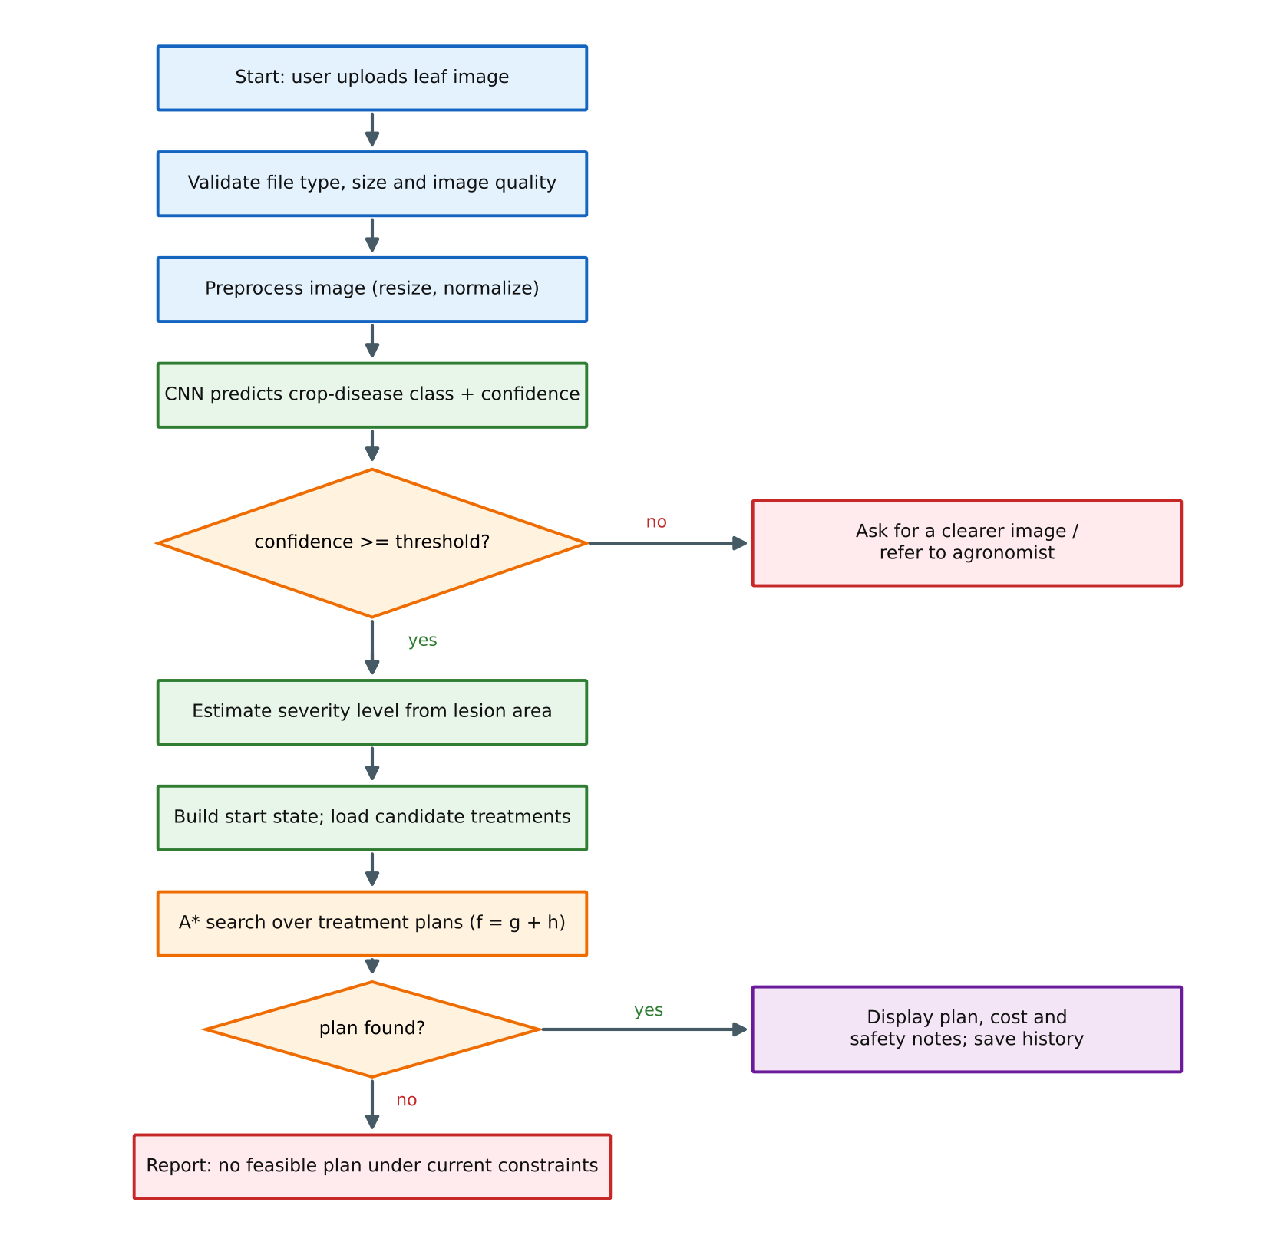
FIGURE 1: Execution workflow of the proposed system
Figure 1 shows the workflow. The figure is a documentation aid and should be checked against the control flow of the actual code before submission.

5.4 Requirements
TABLE 5: Functional requirements
ID | Requirement
FR-01 | The system shall accept a leaf image in common formats (for example JPEG and PNG).
FR-02 | The system shall predict the crop-disease class and display a confidence value.
FR-03 | The system shall refuse to plan treatment when the confidence is below the configured threshold.
FR-04 | The system shall estimate a discrete severity level for the diagnosed leaf.
FR-05 | The system shall generate a minimum-cost treatment plan using A* search.
FR-06 | The system shall display the plan as an ordered list with category, cost and waiting interval of each step.
FR-07 | The system shall independently validate the plan against hard constraints.
FR-08 | The system shall store the history of diagnoses and plans.
FR-09 | The system shall display search statistics such as nodes expanded and plan cost.

TABLE 6: Non-functional requirements
ID | Requirement
NFR-01 | Responsiveness: the diagnosis and plan should be returned in a time acceptable for interactive use; the actual time is to be measured and reported.
NFR-02 | Reliability: invalid input, a missing model file or an internal error shall produce a clear message instead of a crash.
NFR-03 | Usability: results shall use plain language and a clear layout suitable for non-expert users.
NFR-04 | Maintainability: the planner and the knowledge base shall be separate from the web layer so that they can be tested without a browser.
NFR-05 | Transparency: every recommendation shall show the data it was based on, including confidence and cost components.
NFR-06 | Safety: the interface shall display a notice that recommendations must be reviewed by a qualified person before chemical application.

5.5 Expected Outputs
The expected outputs are the predicted disease with its confidence, the estimated severity, the ordered treatment plan with its total cost, the search statistics supported by the implementation, and a stored record in the diagnosis history. A failure to diagnose, a failure to find a plan and an internal error are reported as separate statuses. The report distinguishes expected behaviour from behaviour verified by testing.

5.6 User Guide and Error Handling

5.6.1 Accessing the Application
Open the local development URL or the deployed URL actually used for the project. Confirm that the correct version is running before capturing screenshots. If the deployed build differs from the local source, record which version was tested. Browser and device support should be stated only for those that were tested.

5.6.2 Diagnosing a Leaf
Select a clear photograph in which one leaf fills most of the frame, the lesion is in focus and the lighting is even. Submit the image and wait for the result. If the system asks for a clearer image, retake the photograph with better light, a plain background and the leaf held flat.

5.6.3 Reading the Treatment Plan
The plan lists the steps in the order in which they should be performed, together with the category of each step, its modelled effect, and the waiting interval. The total cost is shown in the normalized cost scale. The cost scale is not a price in rupees unless the knowledge base stores real prices.

5.6.4 Common Errors
A message that the image could not be read may indicate an unsupported file type or a corrupted file. A low-confidence message indicates that the model is not sure of the class, which may happen when the leaf is partially hidden, the picture is blurred, or the disease is not in the training label set. A message that no plan was found indicates that all applicable treatments are excluded by constraints or are insufficient to reach the target severity. Different results for the same photograph on different days may indicate that the model file or the knowledge base was updated. Each symptom should be investigated with a minimal reproducible input.

5.7 Detailed System Workflow
The workflow starts when the user selects an image. The browser sends the image to the Flask endpoint, which first validates the request. Validation should catch missing files, unsupported types, oversized uploads, and images that are too dark or too blurred. Early validation is preferable to passing malformed data to the model, because it produces clearer messages and avoids unnecessary computation.
After validation the preprocessing module resizes the image and applies the same normalization used in training. Using a different normalization at inference time is a frequent source of silent accuracy loss, so the preprocessing function is shared by the training and inference code. The classifier is then invoked and returns a probability vector. The service takes the highest probability as the confidence and compares it with the threshold.
If the diagnosis is accepted, the severity estimator segments the lesion area and computes the lesion-to-leaf ratio. The ratio is converted to a severity level by fixed cut points. The planner receives the disease and the severity, loads the applicable treatments from the knowledge base, computes rho_min, and runs A*. The returned plan is checked by the validator, which re-evaluates the hard constraints without using the search code. This separation matters because a defect shared by the search and the validator could otherwise remain undetected.
Finally, the response is serialized and rendered. The page shows the diagnosis, the plan and the safety notice, and the record is stored in the history. A complete workflow preserves the distinction between invalid input, a low-confidence result, a successful plan, a search that found no plan, and an internal error.

6. SYSTEM ARCHITECTURE AND DESIGN

6.1 Architecture Overview
The system follows a layered architecture, shown in Figure 2. The presentation layer collects images and displays results. The application layer, implemented with Flask, receives requests and calls the AI services. The AI services layer contains the preprocessing code, the classifier, the severity estimator, the A* planner and the plan validator. The data layer stores the trained model, the treatment knowledge base, the diagnosis history and uploaded images. Storage appears in the diagram only to the extent that the implementation actually uses it.
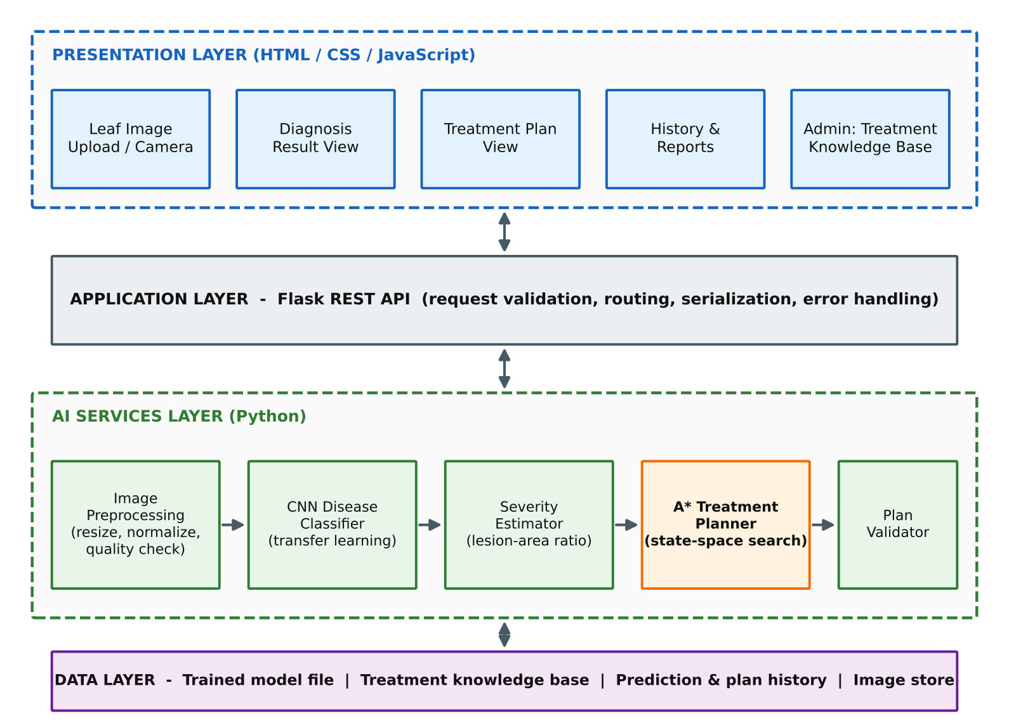
FIGURE 2: Layered architecture of the proposed system

6.2 Presentation Layer
The presentation layer is responsible for image upload, display of diagnosis and treatment plan, history browsing and a simple administrative page for maintaining the knowledge base. The interface should make failure states understandable and should never present a low-confidence diagnosis as if it were certain. Screenshots in the final report should come from the working application and should show the state described in the accompanying text.

6.3 Application Layer
The Flask layer connects browser requests to Python functions. It validates incoming payloads, calls the relevant service and returns a predictable response. Error handling should avoid exposing internal details to end users while keeping useful diagnostic information in development logs. Table 7 lists the conceptual routes. The actual route names must be confirmed from the source code.
TABLE 7: Conceptual API routes (to be reconciled with the source code)
Route | Method | Purpose
/ | GET | Serve the main page
/api/diagnose | POST | Accept an image, return disease, confidence and severity
/api/plan | POST | Given disease and severity, return the A* treatment plan and statistics
/api/history | GET | List stored diagnoses and plans
/api/treatments | GET / POST | Read or update treatment knowledge-base entries (admin)

6.4 AI Services Layer
The services layer is kept independent of the web framework, so that each component can be tested by a plain Python test without starting a server. The classifier wrapper loads the trained model once at start-up, not for each request. The planner exposes a function that accepts a disease identifier, a severity level and an optional configuration, and returns a plan together with a status and statistics. The validator accepts a plan and returns the list of violated constraints, which is empty for a valid plan.

6.5 Data Model
Figure 3 shows the conceptual data model. Each uploaded LeafImage produces a Prediction that refers to a Disease. A TreatmentPlan is generated for a Prediction and is composed of Treatment steps. An Effectiveness record states the modelled severity reduction of a treatment for a disease. The model is conceptual and must be reconciled with the actual storage used, which may be a set of JSON or CSV files, a SQLite database or another store.
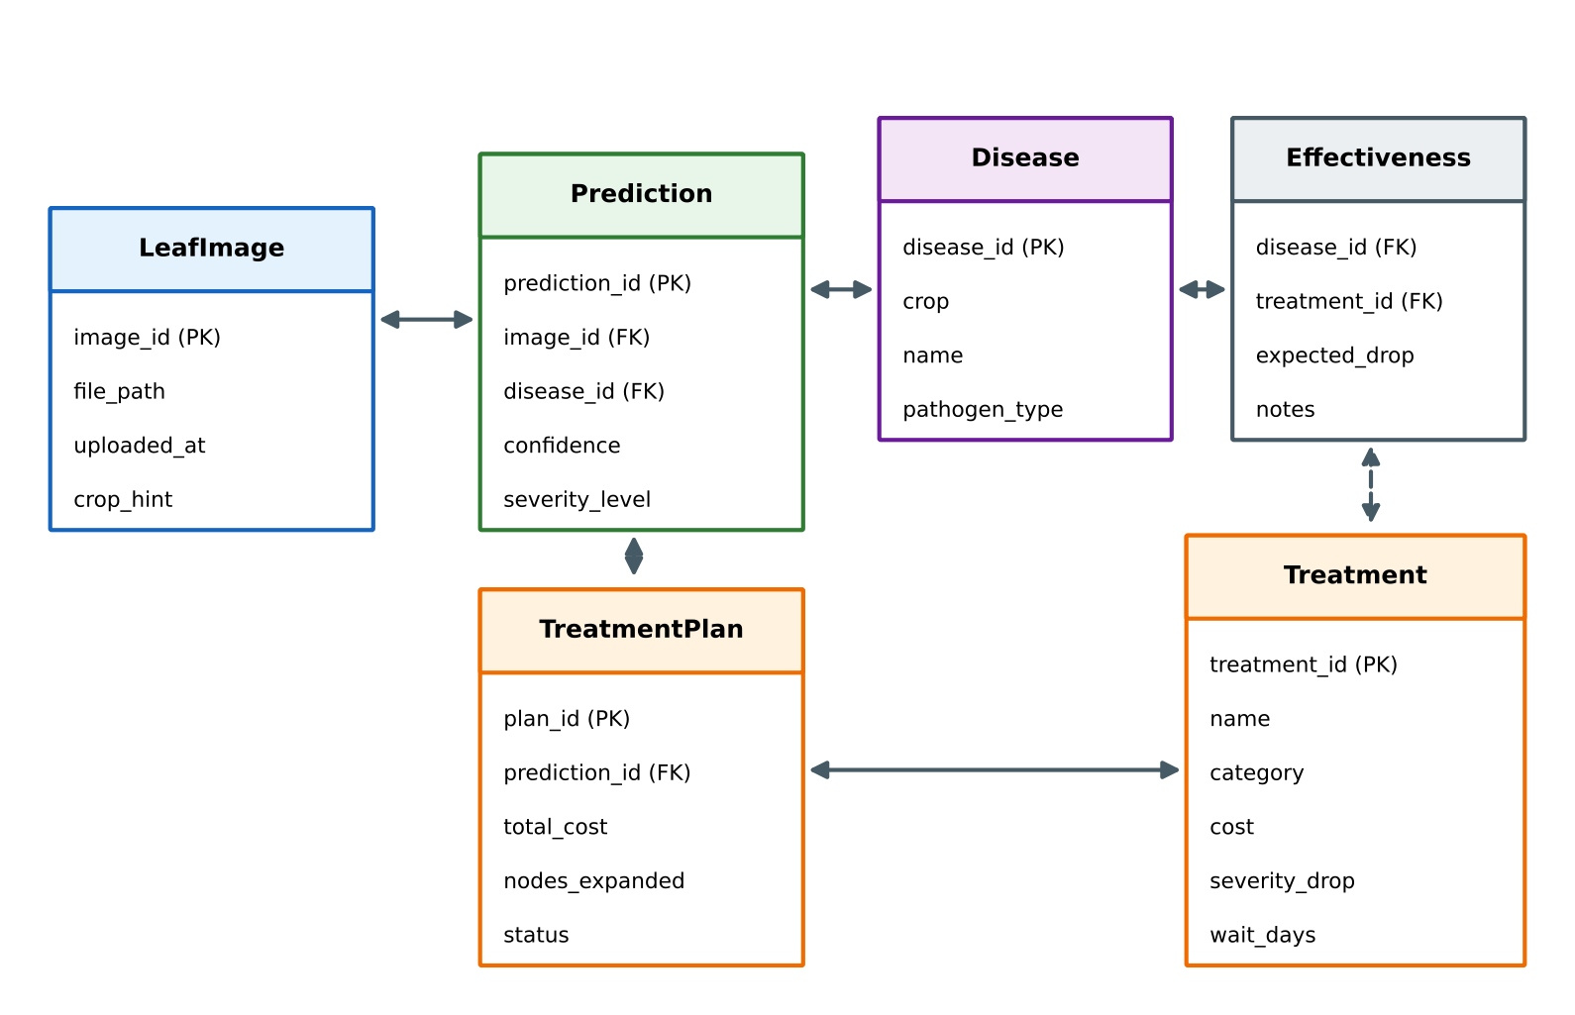
FIGURE 3: Conceptual data model of the application

6.6 Frontend and Backend Responsibilities
The browser interface collects user choices, displays progress and renders returned results. It should not be treated as the authoritative source of correctness: a route may return a plan, but the plan still has to satisfy the encoded constraints. The interface should show clear feedback when a request fails and should avoid displaying a stale result as if it belonged to a new image.
The separation of responsibilities used in this project is the following. The Flask layer validates payloads and serializes results. The planner owns the search and the cost model. The knowledge base owns the facts about treatments. The validator owns the final check of the hard constraints. If the same defective helper were used for both generating and validating a plan, a shared defect might go undetected, so the validator is written to be logically separate from the search code.
These responsibilities can be tested at several levels. Unit tests target the cost function, the heuristic, the successor generator and the validator. Integration tests verify Flask request handling and result serialization. End-to-end tests verify the complete browser workflow. The report maps each test to the layer it covers and should provide evidence from the delivered application.

6.7 Deployment View
For development the application runs as a Flask server on a local machine. A production deployment would place the Flask application behind a production web server, store the model and knowledge base on persistent storage, and restrict the upload size. Because the model is loaded once and inference is a single forward pass, a modest server is sufficient for a small number of users. A mobile or offline deployment would need a smaller model format and is listed as future work.

7. ALGORITHMS

7.1 CNN Disease Classifier
The classifier follows the transfer-learning pipeline shown in Figure 4. A MobileNetV2 base [6] pre-trained on ImageNet is used as the feature extractor. The images are resized to 224 by 224 pixels, augmented during training with random flips, rotations, zoom and brightness changes, and normalized. Global average pooling collapses the spatial feature map into a vector, which is passed through a dense layer with dropout and a final softmax layer with one unit per class. Training is performed in two stages: first only the new classification head is trained while the base is frozen, and then the upper convolutional blocks are unfrozen and fine-tuned at a low learning rate. The architecture is a reference configuration and should be replaced with the one actually used if it differs.
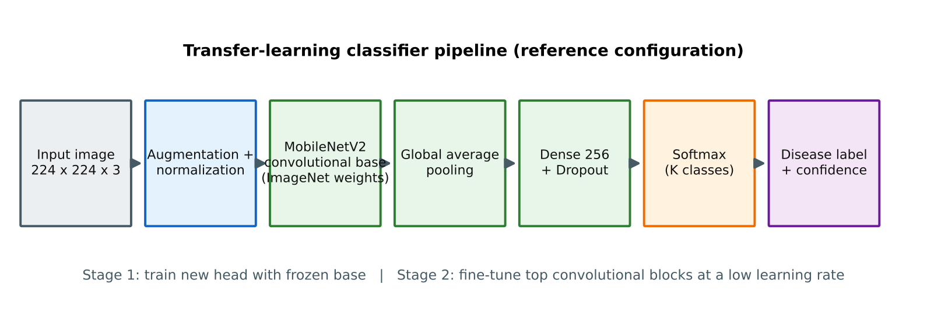
FIGURE 4: Transfer-learning classifier pipeline

7.1.1 Confidence Threshold
A diagnosis is accepted only if the top softmax probability is at least tau. The threshold is selected from the validation set by examining how accuracy of accepted predictions changes with tau, and the chosen value is recorded in the experiment log. A higher tau rejects more uncertain images at the price of asking users to retake photographs more often.

7.1.2 Severity Estimation
Severity is estimated from the lesion area. The leaf is separated from the background, and pixels whose colour lies in a configured range for lesions are counted. The lesion ratio r is the number of lesion pixels divided by the number of leaf pixels. The ratio is converted to a level using cut points: level 0 for a negligible ratio, and levels 1, 2 and 3 for increasing ratios. The cut points are configuration values that must be recorded. This method is simple and transparent, but it is sensitive to lighting and to lesions whose colour resembles healthy tissue, so the severity level should be treated as an approximate input to the planner, not as a laboratory measurement.

7.2 Treatment Knowledge Base
Figure 5 shows how diseases are connected to candidate treatments. Each connection stores the modelled severity reduction for that disease-treatment pair. Table 8 gives an illustrative excerpt of the structure of the knowledge base. The numbers are model parameters for the algorithm demonstration, and they are not agronomic recommendations. Real values must be taken from extension guidelines or agricultural university recommendations and reviewed by an agronomist.
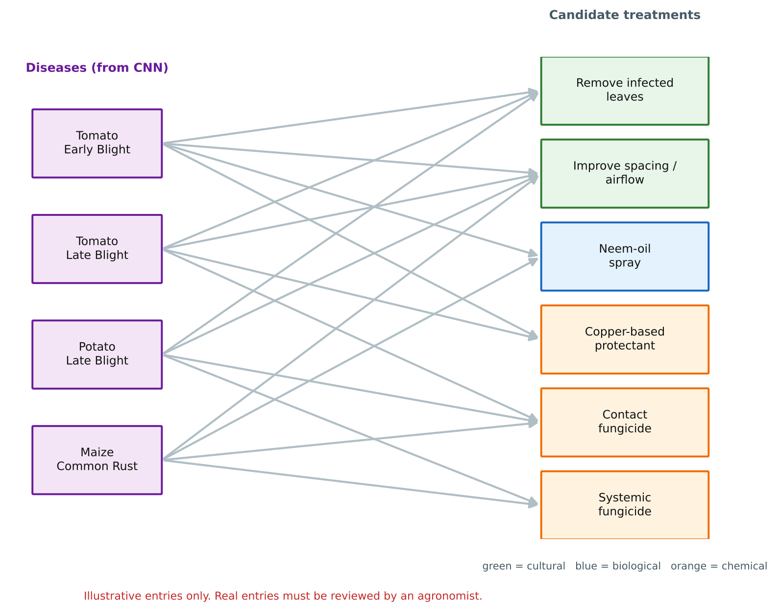
FIGURE 5: Illustrative disease-to-treatment graph of the knowledge base
TABLE 8: Illustrative structure of knowledge-base entries (model parameters, not agronomic advice)
Treatment | Category | Cost | Severity drop | Cost per unit drop | Wait (days)
A: Remove infected leaves | Cultural | 2 | 1 | 2.0 | 0
B: Neem-oil spray | Biological | 3 | 1 | 3.0 | 3
C: Copper-based protectant | Chemical | 5 | 2 | 2.5 | 7
D: Systemic fungicide | Chemical | 8 | 2 | 4.0 | 14

In this illustrative example the smallest cost per unit of severity reduction is rho_min = 2.0, which comes from treatment A. The heuristic is therefore h(n) = 2 * s.

7.3 A* Search for Treatment Planning
A* maintains an open list of generated but unexpanded nodes ordered by f(n) = g(n) + h(n) and a closed set of expanded nodes. In each iteration it removes the node with the smallest f from the open list. If this node is a goal, its path is returned. Otherwise the node is expanded: for each applicable action a successor is generated, its g value is computed by adding the action cost, and it is inserted in the open list unless a path of equal or lower cost to the same state is already known. Ties between equal f values are broken in favour of the node with the smaller h value, which prefers nodes that are closer to the goal and often finds the goal sooner without losing optimality.

7.3.1 Pseudocode
A_STAR_PLAN(disease, s0, config):
actions = knowledge_base.applicable(disease)
rho_min = min(cost(a) / drop(a) for a in actions if drop(a) > 0)
start = Node(sev=s0, used={}, g=0, parent=None)
open = priority_queue(key = (g + rho_min*sev, rho_min*sev))
best_g = { (s0, {}) : 0 }
push(open, start)
while open is not empty:
n = pop_min(open)
if n.sev <= TARGET: return reconstruct_plan(n)
if n is in closed: continue
add n to closed
for a in actions not in n.used:
if incompatible(a, n.used): continue
sev2 = max(0, n.sev - drop(a))
g2 = n.g + cost(a)
key = (sev2, n.used + {a})
if g2 < best_g.get(key, infinity):
best_g[key] = g2
push(open, Node(sev2, n.used + {a}, g2, parent=n, via=a))
return FAILURE # no valid plan exists under the encoded constraints

The pseudocode is a documentation aid and must be reconciled with the actual source code. In particular, the report should state whether the goal test is performed when a node is generated or when it is removed from the open list. Optimality of A* relies on testing at removal, as in the pseudocode above.

7.3.2 Worked Example
Consider the knowledge-base excerpt in Table 8 and an initial severity of 3. Then rho_min = 2 and h(3) = 6. The start node (3, {}) has g = 0 and f = 6. Expanding it generates four successors: using A gives (2, {A}) with g = 2 and f = 6; using B gives (2, {B}) with g = 3 and f = 7; using C gives (1, {C}) with g = 5 and f = 7; and using D gives (1, {D}) with g = 8 and f = 10. The smallest f is 6, so (2, {A}) is expanded next. Its successors are (1, {A,B}) with f = 7, (0, {A,C}) with g = 7 and f = 7, and (0, {A,D}) with g = 10 and f = 10. Among the nodes with f = 7, the tie-break by smaller h selects (0, {A,C}), which is a goal. The returned plan is A followed by C with total cost 7. Table 9 summarizes the trace and Figure 6 shows the search tree.
TABLE 9: A* trace for the worked example
Step | Node removed | g | h | f | Successors generated (f)
1 | (3, {}) | 0 | 6 | 6 | (2,{A}) 6; (2,{B}) 7; (1,{C}) 7; (1,{D}) 10
2 | (2, {A}) | 2 | 4 | 6 | (1,{A,B}) 7; (0,{A,C}) 7; (0,{A,D}) 10
3 | (0, {A,C}) | 7 | 0 | 7 | Goal test succeeds; plan A then C, cost 7

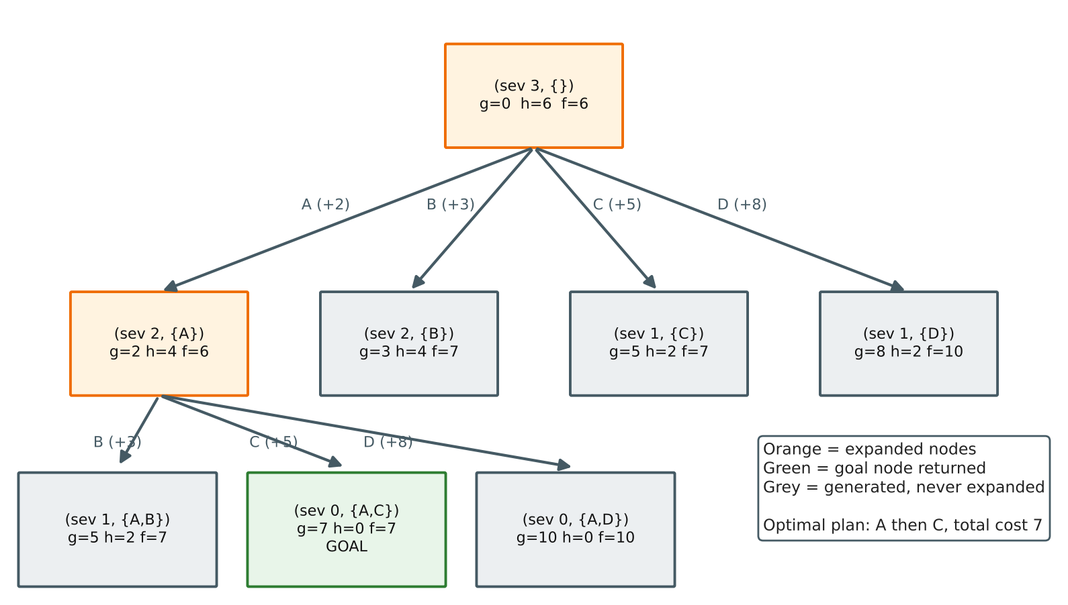
FIGURE 6: A* search tree for the worked example (severity 3)
The result is optimal for this model. The other two-step plans that reach severity 0 are B with C (cost 8), A with D (cost 10), B with D (cost 11) and C with D (cost 13), and the three-step plan A, B, C costs 10. The plan A followed by C, with cost 7, is therefore the cheapest. It is found after two node expansions, whereas uniform-cost search would have to expand every node whose g value is below 7 before it could stop.

7.4 Properties of the Planner
Completeness. The state space is finite, because severity takes four values and each treatment can be used once. Every action has positive cost, and A* with a closed set therefore terminates. If a valid plan exists it will be found. Optimality. Since h is admissible and consistent, the first goal removed from the open list has minimum path cost among all valid plans in the model. Time complexity. In the worst case the number of generated nodes is bounded by the size of the state space, which is at most 4 * 2^m for m treatments, so the worst-case time is exponential in m. In practice m is small and the heuristic reduces the number of expansions. Space complexity. A* stores all generated nodes, so memory is also bounded by the size of the state space.

7.5 Comparison of Search Methods
TABLE 10: Qualitative comparison of methods for treatment planning
Method | Uses cost | Uses heuristic | Optimal plan | Remark
Fixed lookup table | No | No | Not applicable | Simple, cannot adapt to severity or cost
Breadth-first search | No | No | Fewest steps only | Ignores cost differences
Uniform-cost search (Dijkstra) | Yes | No | Yes | Baseline; may expand many nodes
Greedy best-first search | No | Yes | No | Fast but can return expensive plans
A* search | Yes | Yes (admissible) | Yes | Optimal within the model; fewer expansions expected

The table is qualitative. Whether A* actually expands fewer nodes than uniform-cost search on the project’s instances is an empirical question that is addressed by the experimental plan in Chapter 10, not by this table.

7.6 Parameters of the Planner
TABLE 11: Planner and classifier parameters to be recorded
Parameter | Meaning | Reference value / status
tau | Confidence threshold | To be chosen from validation data
s* | Target severity | 0
w1 to w4 | Cost weights | To be recorded from configuration
Tie-break rule | Order among equal f | Smaller h first
Cut points | Lesion-ratio limits for severity levels | To be recorded from code
Seed | Random seed for training and splits | To be recorded

7.7 Why the Heuristic Must Be Recomputed
Because rho_min is computed from the actions that are applicable to the diagnosed disease, any change in the knowledge base can change its value. If a new low-cost treatment is added and rho_min is not recomputed, the old value would be larger than the true minimum and the heuristic could overestimate the remaining cost. This would make the search faster but could return a plan that is not optimal. The implementation therefore computes rho_min at the start of every search and does not cache it across knowledge-base updates.

7.8 Algorithm Walkthrough Checklist
To demonstrate correctness during evaluation, the authors should prepare small instances whose result can be derived by hand, such as the worked example above. For each instance the expected plan and expected number of expansions should be recorded in advance, and the program output should be compared with them. The checklist includes: an instance with a single applicable treatment; an instance in which the cheapest plan uses two cheap steps rather than one expensive step; an instance in which two treatments are incompatible; an instance in which no plan can reach the target; and an instance with equal-cost plans, to confirm that tie-breaking is deterministic.

8. IMPLEMENTATION DETAILS

8.1 Development Approach
The application is developed incrementally. The dataset is examined first, then the classifier is trained and evaluated offline, then the planner is implemented and tested on small hand-derived instances, and only then are the components connected to Flask routes and the browser interface. This order allows each component to be validated before it depends on another.

8.2 Technology Stack
TABLE 12: Technology stack (reference; verify names and versions against the project)
Component | Technology | Role
Programming language | Python | Classifier, planner, services
Deep learning library | TensorFlow / Keras [17] | Model definition, training and inference
Image processing | OpenCV / Pillow | Loading, resizing, lesion segmentation
Web framework | Flask [18] | HTTP routes and integration
Front end | HTML, CSS, JavaScript | User interface
Data storage | JSON / CSV or SQLite | Knowledge base and history
Evaluation | scikit-learn [20] | Metrics such as precision, recall and confusion matrix

Library names and versions should be added only after they are verified in the project’s requirements file.

8.3 Dataset
The classifier is trained on a public labelled collection of leaf images, such as the PlantVillage dataset [4], or on a dataset assembled by the authors. The dataset must be described accurately in the final report: its source, licence, number of classes, number of images per class, the split between training, validation and test sets, and how duplicate or near-duplicate images are handled so that the test set is not contaminated by images that are almost identical to training images. Table 13 is a template that should be filled with the actual values.
TABLE 13: Dataset description template
Item | Value
Dataset name and source | [to be filled]
Number of crops / classes | [to be filled]
Total images | [to be filled]
Training / validation / test split | [to be filled]
Class balance (min and max images per class) | [to be filled]
Image resolution and background type | [to be filled]
Random seed for splitting | [to be filled]

8.4 Training Configuration
Table 14 lists the settings that should be recorded for the trained model. The reference choices are a MobileNetV2 base, an Adam optimizer [21], a categorical cross-entropy loss and early stopping on validation loss. These must be replaced by the values used in the actual training script.
TABLE 14: Training configuration to be recorded
Setting | Reference choice | Value used
Input size | 224 x 224 x 3 | [confirm]
Base network | MobileNetV2 (ImageNet weights) | [confirm]
Optimizer | Adam | [confirm]
Learning rate (head / fine-tune) | Higher for head, low for fine-tuning | [confirm]
Loss function | Categorical cross-entropy | [confirm]
Batch size and epochs | To be selected | [confirm]
Augmentation | Flip, rotation, zoom, brightness | [confirm]
Early stopping | On validation loss | [confirm]

8.5 Implementation of the A* Planner
The planner is implemented as a standalone Python module. A node stores the severity level, the frozen set of used treatments, the path cost and a reference to the parent node and the action that produced it. The open list is a binary heap keyed by f and then by h. A dictionary maps each state to the lowest g value found so far, which prevents duplicate states from being pushed with a worse cost. A counter records the number of nodes generated and expanded so that the statistics shown in the interface are consistent with the search. The definition of each counter is fixed: “generated” counts each successor that is pushed to the open list, and “expanded” counts each node removed from the open list that is not already in the closed set.

8.6 Data Generation and Reproducibility
For planner experiments the knowledge base can be generated synthetically so that the number of treatments, the cost range and the severity drops can be controlled. Random seeds are recorded so that an instance can be regenerated. For classifier experiments the random seed of the split and of training should be recorded and, where possible, the training should be repeated with several seeds. The repeatability protocol should record the source commit or application version, the operating system, the Python and library versions, the dataset identifier, the configuration and the timing boundary.

8.7 Screenshot Evidence Register
The following figures are placeholders and must be replaced with screenshots captured from the final build. Each screenshot should have a descriptive caption and a sentence in the body text that explains what it shows. Synthetic or public images should be used to avoid exposing private information.
[ INSERT SCREENSHOT / CHART HERE ]
Capture the main page with the upload control and navigation
FIGURE 7: Application dashboard (home page)
[ INSERT SCREENSHOT / CHART HERE ]
Capture the result page for a correctly classified leaf
FIGURE 8: Disease diagnosis result with confidence
[ INSERT SCREENSHOT / CHART HERE ]
Capture the ordered plan, total cost and search statistics
FIGURE 9: Treatment plan generated by the A* planner
[ INSERT SCREENSHOT / CHART HERE ]
Capture the rejected-image message and the history table
FIGURE 10: Low-confidence message and diagnosis history

8.8 Data Model and Field Validation
Identifiers should be stable and unique. Duplicate treatment identifiers could cause one treatment to overwrite another in the knowledge base, so the loader should reject duplicates. Costs and severity drops should be validated as non-negative numbers, and every treatment with a severity drop of zero should be rejected or ignored by the heuristic computation, because it cannot contribute to reaching the goal. References from the Effectiveness table to unknown diseases or treatments should produce a clear error before any search begins.
Input validation should distinguish between a missing field, an invalid type, an unknown identifier, an empty set of applicable treatments, and a valid but infeasible instance. These conditions are different and should not be reported by one generic failure label. Uploaded images should be stored with generated file names, not with names supplied by the user, and the upload size should be limited.
Data minimization is important even in a prototype. If real farm data or geo-tagged photographs are introduced in the future, access permissions, anonymization, retention and authorization must be reviewed before use.

8.9 Troubleshooting and Failure Analysis
If the classifier predicts a wrong class for a clear image, first check that the preprocessing used at inference time is identical to that used in training, including the colour order and the normalization range. Then check that the label order in the label file matches the order of the output units. If the planner returns no plan, confirm that the disease has applicable treatments, that the target severity is reachable with the available drops, and that the compatibility rules do not exclude every combination. If the plan cost differs from a hand calculation, check that rho_min is not being cached and that the cost weights in the configuration are the ones assumed in the calculation.
If the interface shows a result for the previous image after a new upload, the front end may be displaying stale data and should clear its state at the start of each request. If statistics look inconsistent, identify exactly when counters are incremented and reset, because a counter that accumulates across runs gives misleading values. Compare the interface values with the raw backend log for a known test case.

9. TESTING AND VALIDATION

9.1 Testing Objectives
Testing should verify that the classifier pipeline is applied consistently, that the planner returns plans satisfying the modelled hard constraints, that the plan is optimal on instances whose answer is known, that the independent validator detects invalid plans, and that the interface displays results and statistics that correspond to the backend output. A screenshot supports a test but does not replace assertions or independent validation.

9.2 Unit Testing
Unit tests cover individual functions with small known inputs. For the planner they include: the cost function with known weights; the computation of rho_min; the successor generator, including exclusion of used and incompatible treatments; the goal test; and the validator. For the classifier pipeline they include: preprocessing output shape and value range, label-file ordering, and the confidence-threshold decision. For severity estimation they include synthetic images with a known lesion ratio, for which the expected level is obvious.

9.3 Integration Testing
Integration tests confirm that Flask routes pass valid data to the services and return the format expected by the front end. They cover successful diagnosis, low-confidence rejection, unsupported file types, oversized uploads, a disease without treatments, and an internal error. They also verify that statistics are not silently omitted or mislabelled.

9.4 Test Case Summary
TABLE 15: Test case summary (statuses to be filled after execution)
ID | Test description | Expected behaviour | Status
TC-01 | Single applicable treatment, severity 1 | Plan contains exactly that treatment | Pending
TC-02 | Worked example of Table 8, severity 3 | Plan A then C, cost 7, 2 expansions | Pending
TC-03 | Treatment pair marked incompatible | Pair never appears together | Pending
TC-04 | Target unreachable with available drops | Status: no plan found | Pending
TC-05 | Equal-cost alternative plans | Deterministic tie-break result | Pending
TC-06 | Heuristic admissibility on random instances | h(n) not greater than optimal remaining cost | Pending
TC-07 | A* cost equals uniform-cost-search cost | Same optimal cost on all test instances | Pending
TC-08 | Confidence below threshold | No plan; user asked for a clearer image | Pending
TC-09 | Corrupted or unsupported image file | Clear error message, no crash | Pending
TC-10 | Displayed statistics equal backend counters | Values match for known case | Pending

9.5 Extended Test Cases
The extended specification includes: TC-11 empty input; TC-12 malformed input; TC-13 duplicate treatment identifier in the knowledge base; TC-14 treatment with zero severity drop; TC-15 negative cost rejected by the loader; TC-16 repeated run with a fixed seed gives the same plan; TC-17 large synthetic knowledge base with many treatments; TC-18 plan validator detects an injected repeated treatment; TC-19 plan validator detects an injected incompatible pair; TC-20 plan validator accepts a known valid plan; TC-21 history record matches the displayed result; TC-22 two consecutive uploads do not mix results; TC-23 very dark image rejected; TC-24 very blurred image rejected; TC-25 healthy leaf produces a no-treatment message; TC-26 image of a non-leaf object gives a low-confidence or out-of-scope result; TC-27 image from a different crop than expected; TC-28 maximum upload size; TC-29 concurrent requests; TC-30 missing model file at start-up.
The expected behaviour in each case is a test specification, not proof that the test passed. The execution record for each test should contain the input, expected behaviour, actual behaviour, pass or fail status, date, application version and evidence. Failed test evidence should be preserved and explained as a defect, an unsupported constraint or a limitation.

9.6 Validation of the Heuristic
Because the optimality guarantee depends on admissibility, the heuristic deserves a direct test. For many small randomly generated knowledge bases, the true remaining cost from every state can be computed by exhaustive search. The test then asserts that h(n) is not greater than that true cost for every state, and that the consistency inequality h(n) <= cost(a) + h(n') holds for every transition. A single violation indicates either a defect in the heuristic or a violated assumption, such as a treatment with a drop larger than the severity scale or a cost below the one used to compute rho_min.

9.7 Regression Testing
After any change to the knowledge base loader, the cost function, the preprocessing code or the model file, the relevant tests are rerun. A change to the preprocessing normalization affects all predictions, and a change to the cost weights affects all plans. Regression tests should include the worked example, because it exercises successor generation, the heuristic, tie-breaking and plan reconstruction in a single small instance.

9.8 Classifier Evaluation Metrics
Classifier quality is measured on a held-out test set that was not used for training or for tuning the threshold. The report should present overall accuracy, per-class precision, recall and F1 score, and the confusion matrix. Overall accuracy can hide poor performance on rare classes, so per-class results are required. The proportion of test images rejected by the confidence threshold and the accuracy among the accepted images should also be reported, because together they describe the trade-off controlled by tau.

9.9 User Interface Evaluation
The interface should make the result understandable without requiring the user to read source code. The diagnosis should show the disease name, the confidence and the severity. The treatment plan should show the order of steps, the category and cost of each step, and the waiting intervals. Error messages should communicate the type of problem: an unreadable image is different from a low-confidence image, and a low-confidence image is different from a diagnosis for which no plan exists.
Usability can be examined with a short task list: open the application, upload a photograph, read the diagnosis, read the plan, open the history, and upload a poor-quality image. Observations should be reported as qualitative evidence only if real users performed the tasks. Accessibility and readability should be considered: headings should be meaningful, text should remain legible on a small screen, controls should have labels, and colour should not be the only way to convey severity. Responsive layout and keyboard navigation can be listed as future work if they have not been verified.

10. EXPERIMENTAL EVALUATION

10.1 Evaluation Questions
- RQ1. How accurately does the classifier identify disease classes on a held-out test set, and how does accuracy among accepted images change with the confidence threshold?
- RQ2. How does classification accuracy change on photographs taken outside the training distribution, for example with complex backgrounds?
- RQ3. Does A* with the proposed heuristic return the same optimal cost as uniform-cost search on all test instances?
- RQ4. Does A* expand fewer nodes than uniform-cost search, and how does the difference change as the number of treatments grows?
- RQ5. How does the plan change when the cost weights favour low toxicity or low monetary cost?

10.2 Experimental Setup
The classifier experiments use the dataset described in Chapter 8, with a fixed split and recorded seeds. The planner experiments use the hand-derived instances of Chapter 7 and synthetic knowledge bases with increasing numbers of treatments. The planner configurations compared on identical inputs are listed in Table 16. All configurations use the same hard constraints, the same cost function and the same timing boundary.
TABLE 16: Planner configurations compared
Config | Description | Purpose
A | Breadth-first search | Uninformed baseline (fewest steps)
B | Uniform-cost search (A* with h = 0) | Optimal baseline without heuristic
C | Greedy best-first search using h | Shows the effect of ignoring g
D | A* with h = rho_min * severity | Proposed planner

10.3 Metrics
For the classifier: accuracy, per-class precision, recall and F1 score, the confusion matrix, the rejection rate at the chosen threshold and the accuracy among accepted images. For the planner: total plan cost, number of nodes generated, number of nodes expanded, runtime, solver status, and hard-constraint violations found by the independent validator. Each metric must be defined before data is collected. A node count is meaningful only if the definition of a generated and an expanded node is the same in every configuration.

10.4 Experimental Data Template
[NO MEASUREMENTS PROVIDED YET. Populate Table 17 and Table 18 after running the application.] The values below are intentionally blank.
TABLE 17: Classifier results template
Metric | Value
Overall test accuracy
Macro-averaged F1 score
Rejection rate at the chosen tau
Accuracy among accepted images
Accuracy on field-condition photographs

TABLE 18: Planner results template
Instance | m | Config | Plan cost | Nodes gen. | Nodes exp. | Runtime | Violations
 |  | A
 |  | B
 |  | C
 |  | D

10.5 Fair Comparison
Every configuration should use the same input instance and hard constraints. The same independent validator should evaluate all returned plans. Runtime should be measured with the same timing boundary, excluding browser rendering unless the metric explicitly includes it. For very small instances the runtime is below the resolution of a timer, so each run should be repeated many times and the aggregation method reported. Node counts are more stable than runtime and should be reported as the primary measure of search effort.

10.6 Experimental Run Log
For each run record: run identifier, dataset or instance identifier, seed, number of treatments, configuration, date and time, plan cost, nodes generated, nodes expanded, runtime, solver status, hard-constraint violations and the application version. Raw logs should be retained before summary statistics are calculated, and failed runs should be reported with an explanation.

10.7 Evaluation Plan and Interpretation

10.7.1 Classifier Experiments
Train the model with the recorded configuration, select tau on the validation set, and evaluate once on the test set. If several seeds are used, report the mean and the spread. A separate small set of photographs taken under realistic conditions, if available, should be evaluated separately because accuracy on laboratory-style images is not expected to transfer unchanged to field images [15].

10.7.2 Planner Optimality Experiments
Run configurations B and D on all instances and confirm that their plan costs are identical. Any difference is a defect in the heuristic or in the closed-set logic and must be investigated. Run configuration A and C as well to show that fewest-step plans and greedy plans may cost more than the optimal plan.

10.7.3 Scaling Experiments
Generate synthetic knowledge bases with an increasing number of treatments, for example from four to sixteen, using fixed seeds. For each size, report the median number of expanded nodes for configurations B and D over repeated instances. The expected behaviour is that the benefit of the heuristic grows with problem size, but this is a hypothesis to test and not a result.

10.7.4 Weight Sensitivity
Vary one cost weight at a time and record how the plan changes. This shows whether the planner reacts sensibly to preferences, for example by replacing a chemical treatment with a biological one when the toxicity weight increases. It also reveals whether the result is dominated by a single component.

10.7.5 Result Narrative
Once measurements are available, describe each observation, cite the table or figure, and state the conditions under which it holds. Avoid universal claims from a small sample of synthetic instances or from a single public dataset.

11. RESULTS AND DISCUSSION

11.1 Current Evidence Status
The system design, algorithms and evaluation procedure are documented in this report. Quantitative results for the classifier and the planner have not yet been entered. This draft therefore does not claim a particular accuracy, a particular speed-up or a particular reduction in treatment cost. Final claims must be based on runs of the working application, and every number in this chapter must be traceable to a log.

11.2 Expected Behaviour of the Techniques
Transfer learning is expected to reach useful accuracy with less training data than training from scratch. A* with an admissible and consistent heuristic is guaranteed to return a minimum-cost plan within the model, and is expected to expand no more nodes than uniform-cost search for the same tie-breaking rule. Greedy best-first search is expected to be fast but may return more expensive plans. These statements describe the techniques in general and are not experimental findings for this implementation.

11.3 How to Interpret Results
If the classifier achieves high accuracy on the test split but lower accuracy on field photographs, the report should state this clearly and explain it by the difference in background and lighting [15]. If the rejection rate is high at a chosen threshold, discuss whether the model is under-trained or the images are of low quality. If A* and uniform-cost search return the same cost on every instance but A* expands fewer nodes, report the median reduction and the instance sizes. If A* does not expand fewer nodes on very small instances because the overhead of computing the heuristic is larger than the saving, report that honestly; this is an expected outcome for tiny problems. If results differ from expectations, report and investigate the discrepancy.

11.4 Result Figures and Tables
[ INSERT SCREENSHOT / CHART HERE ]
Insert a labelled confusion matrix generated from measured predictions
FIGURE 11: Confusion matrix of the classifier on the test set
[ INSERT SCREENSHOT / CHART HERE ]
Insert a chart generated from the measurements; label axes and state the dataset
FIGURE 12: Nodes expanded versus number of treatments for each planner configuration
Do not replace missing measurements with illustrative values. Label all axes, state the dataset size and the configuration, and include the number of repetitions.

11.5 Summary
The final discussion should separate verified correctness, measured performance and theoretical expectations. A plan is optimal only relative to the encoded model and is valid only relative to the hard constraints checked by the independent validator. Results from a public image dataset should not be generalized to all fields, crops, seasons and cameras.

11.6 Evidence and Submission Readiness

11.6.1 Academic Formatting
Confirm the project title, course title, student names, roll numbers, department, supervisor and submission date on the cover page and certificate. Insert the official college logo. Update the table of contents and the lists of figures and tables after final pagination. Check page numbering, margins, typography, spelling and reference formatting.

11.6.2 Technical Evidence
Replace placeholder figures with real screenshots of the dashboard, diagnosis result, treatment plan and history. Verify every listed module, route, parameter and constraint against the source code. State the actual dataset and training settings.

11.6.3 Evaluation Integrity
Run the test cases and replace pending statuses with actual outcomes. Collect measurements rather than inventing accuracy or runtime values. Preserve raw logs and identify unresolved limitations. Verify that the heuristic is admissible on the final knowledge base.

11.7 Final Evidence Register
The final report should contain a register that links each important claim to evidence. For a claim that the system diagnoses leaf images, evidence includes the evaluation on the test set and a screenshot. For a claim that the planner returns an optimal plan, the evidence includes the hand-derived instance, the admissibility test and the comparison with uniform-cost search. For a claim about speed, retain the raw logs with instance identifiers, configuration and environment, and do not omit failed runs without explanation. If a metric is not available in the current application, state this limitation and either instrument the code or exclude the metric. Do not infer correctness merely because the interface displays a plan.

12. LIMITATIONS AND RISK ANALYSIS

12.1 Dataset and Generalization Limitation
Public leaf-image datasets are often photographed with plain backgrounds and uniform light. A classifier trained on such images may perform worse on photographs taken in a field, with soil, other plants, shadows, water drops or multiple diseases on one leaf [15]. The model can recognize only the classes present in its label set, and it may confidently assign a wrong class to a disease it has never seen.

12.2 Model Completeness
A planner cannot enforce a rule that is absent from its model. The knowledge base omits local regulations, approved chemical lists, crop growth stage, weather, soil condition, spray equipment, farmer budget limits, and the interactions between several diseases that occur at the same time. A plan may therefore be optimal within the model and still be unsuitable for a particular farm.

12.3 Severity Estimation Limitation
The lesion-area ratio is a rough proxy for infection severity. It depends on image segmentation quality, lighting and the camera. It does not capture infection of other plant parts, spread through the field, or the stage of the disease. The planner’s guarantee does not extend to errors in the severity estimate.

12.4 Knowledge-Base Quality
The cost and severity-drop values are only as accurate as the data entered. In the current prototype they are model parameters. If they are inaccurate, the plan will be optimal for the wrong problem. The values must be taken from authoritative extension sources, reviewed by an agronomist, and updated as guidance changes.

12.5 Algorithmic Limitations
A* has worst-case exponential time and memory in the number of treatments. This is not a problem for the small knowledge bases of the prototype, but it would need attention for large ones. Optimality depends on admissibility, so careless changes to costs or drops can silently remove the guarantee unless the heuristic is recomputed and tested.

12.6 Risk Register
TABLE 19: Risk analysis register
No. | Risk | Impact | Mitigation
R1 | Misclassification of a disease | Wrong treatment recommended | Confidence threshold, safety notice, expert review
R2 | Accuracy drop on field photographs | Poor real-world reliability | Evaluate separately; add field images to training in future
R3 | Heuristic not admissible after knowledge-base change | Plan not optimal | Recompute rho_min per search; admissibility test
R4 | Inaccurate costs or drops in knowledge base | Plan optimal for wrong data | Source from guidelines; agronomist review
R5 | Inconsistent preprocessing at inference | Silent accuracy loss | Shared preprocessing code; regression tests
R6 | Misleading performance claims | Unsupported conclusions | Define metrics, retain raw logs, report failures
R7 | Unclear failure states | Timeout read as infeasibility | Separate statuses for each outcome
R8 | Harmful over-reliance on the tool | Chemical misuse | Display warnings; not a substitute for expert advice
R9 | Inaccurate documentation | Report describes missing features | Trace each claim to code or test evidence

12.7 Ethics, Safety, and Operational Boundaries
A recommendation about pesticides has safety implications for farmers, consumers and the environment. The application is an academic prototype and must not be presented as an authoritative agricultural advisory service. The interface should display a clear notice that recommendations require review by a qualified agronomist, that product labels and local regulations must be followed, and that protective equipment and waiting intervals must be respected. The prototype should prefer lower-impact options where the model allows it.
Uploaded photographs may contain location information in their metadata or may show people or property. A prototype should strip unnecessary metadata, limit retention and use public or synthetic images for demonstrations. If real farm data is used in future, access, storage, retention and removal must be defined. Transparent reporting is also an ethical requirement: accuracy figures, test statuses, screenshots and references should reflect real evidence, and placeholders should stay clearly marked until replaced.

12.8 Extended Discussion of Limitations
The first limitation is model fidelity. Real treatment decisions depend on many factors that the prototype does not represent, and a plan that is feasible in the model may be unsuitable in practice. The second limitation is dataset representativeness. The distribution of images in a public dataset differs from the distribution of images that farmers will upload. The third limitation is that a single image may not contain enough information: some diseases are only distinguishable by symptoms on other plant parts, or by field context.
The fourth limitation is evaluation coverage. Unit tests can verify selected cases but cannot prove that every possible plan is valid. Independent validation reduces the risk of hidden defects, while end-to-end testing verifies that data passes correctly through the interface and backend. The fifth limitation is operational readiness. A classroom prototype may lack authentication, role-based access, monitoring, backup, audit trails and integration with agricultural advisory systems. These capabilities should be treated as future requirements, not implied features.

13. FUTURE WORK

13.1 Field-Image Robustness
Collect and label photographs taken in real fields with complex backgrounds, and include them in training and evaluation. Techniques such as stronger augmentation, background removal and domain adaptation can be compared on a separate field test set.

13.2 Explainable Diagnosis
Add Grad-CAM heat maps [11] to the result page so that the user can see which part of the leaf supports the prediction. Use the heat maps during development to detect shortcuts, for example a classifier that responds to the background.

13.3 Learned Severity Estimation
Replace the colour-threshold severity estimator with a trained segmentation or regression model, and compare it with expert-labelled severity. The planner interface would remain unchanged.

13.4 Richer Planning Model
Extend the state with the crop growth stage, the number of days to harvest, weather forecast and treatment schedules over several days. Study stronger heuristics derived from relaxed problems [12], and compare with alternatives such as weighted A* for large knowledge bases when optimality can be traded for speed.

13.5 Uncertainty in Treatment Effect
The current model uses fixed expected reductions. A future version could represent the effect of a treatment as a probability distribution and plan with Markov decision processes, or re-plan after the user uploads a follow-up photograph that shows how the infection responded.

13.6 Multi-Disease and Multi-Crop Support
Extend the classifier to multi-label output so that leaves with more than one disease can be handled, and extend the planner to find treatments that address several diseases at once at minimum combined cost.

13.7 Mobile and Offline Deployment
Convert the classifier to a lightweight mobile format so that diagnosis can run on a phone without internet access, and provide local-language output for farmers. Voice output could improve accessibility for users with limited literacy.

13.8 Localization of the Knowledge Base
Create region-specific knowledge bases that follow local guidelines, approved products and market prices, with a maintenance interface for agricultural experts. A review workflow with version history would make the data auditable.

13.9 Real-World Evaluation
With appropriate permission and privacy safeguards, evaluate the system with agronomists and farmers, comparing its diagnoses and plans against expert opinion. Establish a trusted baseline and evaluate both correctness and practical usefulness before any deployment decision.

14. LEARNING OUTCOMES

14.1 Understanding Search Problems
The project provides practical experience in defining a search problem with states, actions, costs and a goal test, and in proving that a heuristic is admissible and consistent.

14.2 Heuristic Search
Implementing A* demonstrates how the evaluation function f = g + h guides the search, how tie-breaking affects the trace, and why a closed set and a consistent heuristic are important for efficiency and optimality.

14.3 Machine Learning for Vision
Training a CNN with transfer learning gives experience of dataset preparation, augmentation, fine-tuning, threshold selection, and the interpretation of precision, recall and confusion matrices.

14.4 Software Integration
Building the Flask back end and the browser interface connects model inference, search algorithms, data storage and result presentation. It also shows the importance of consistent preprocessing between training and inference.

14.5 Responsible AI Practice
The project reinforces the need to communicate uncertainty, to separate model-relative guarantees from real-world claims, to report measurements honestly, and to consider safety and privacy when an AI system gives advice that affects people and the environment.

15. CONCLUSION
The AI-Powered Crop Disease Detection and Treatment Recommendation System combines image-based diagnosis with search-based treatment planning. A convolutional neural network identifies the crop disease from a leaf image, a confidence threshold prevents uncertain diagnoses from producing recommendations, and a severity estimator converts the visible damage into a discrete level. The A* algorithm then searches a well-defined state space to find the minimum-cost treatment plan, using a heuristic based on the cheapest cost per unit of severity reduction. This heuristic was shown to be admissible and consistent, which gives the planner a clear optimality guarantee within its model.
The report separates three kinds of statements: what the design guarantees in theory, what has been verified by tests, and what has been measured. Quantitative measurements for the classifier and for the planner have not yet been entered; therefore this report does not claim a particular accuracy or speed advantage. The evaluation procedure in Chapter 10 specifies the datasets, configurations, metrics and logs needed to produce those results honestly.
The prototype is not a replacement for expert agricultural advice. Its value lies in showing how a perception model and a classical AI search algorithm can be combined into a transparent decision-support pipeline, and in providing a base that can be extended with field images, explainability, richer planning models and region-specific knowledge.

16. ACKNOWLEDGEMENT
We express our sincere gratitude to our faculty guide, [FACULTY NAME], for her guidance and support throughout the development of this project. Her suggestions helped shape the objectives and the technical presentation of the work.
We thank the Department of Computer Science and Engineering, [COLLEGE NAME], for providing the academic environment to study artificial intelligence and apply its problem-solving techniques to a practical agricultural problem.
We acknowledge the researchers and authors whose work on plant disease recognition, deep learning and heuristic search provides the theoretical foundation for this project, and the creators of the public datasets and open-source tools that made it possible. Finally, we thank everyone who offered feedback and assistance during development and documentation.

17. REFERENCES
[1] S. Russell and P. Norvig, Artificial Intelligence: A Modern Approach, 4th ed. Pearson, 2021.
[2] P. E. Hart, N. J. Nilsson, and B. Raphael, “A formal basis for the heuristic determination of minimum cost paths,” IEEE Transactions on Systems Science and Cybernetics, vol. 4, no. 2, pp. 100–107, 1968.
[3] S. P. Mohanty, D. P. Hughes, and M. Salathé, “Using deep learning for image-based plant disease detection,” Frontiers in Plant Science, vol. 7, Art. 1419, 2016.
[4] D. P. Hughes and M. Salathé, “An open access repository of images on plant health to enable the development of mobile disease diagnostics,” arXiv:1511.08060, 2015.
[5] A. G. Howard et al., “MobileNets: Efficient convolutional neural networks for mobile vision applications,” arXiv:1704.04861, 2017.
[6] M. Sandler, A. Howard, M. Zhu, A. Zhmoginov, and L.-C. Chen, “MobileNetV2: Inverted residuals and linear bottlenecks,” in Proc. IEEE/CVF Conf. Computer Vision and Pattern Recognition (CVPR), 2018, pp. 4510–4520.
[7] K. He, X. Zhang, S. Ren, and J. Sun, “Deep residual learning for image recognition,” in Proc. IEEE Conf. Computer Vision and Pattern Recognition (CVPR), 2016, pp. 770–778.
[8] K. Simonyan and A. Zisserman, “Very deep convolutional networks for large-scale image recognition,” in Proc. Int. Conf. Learning Representations (ICLR), 2015.
[9] Y. LeCun, Y. Bengio, and G. Hinton, “Deep learning,” Nature, vol. 521, pp. 436–444, 2015.
[10] A. Krizhevsky, I. Sutskever, and G. E. Hinton, “ImageNet classification with deep convolutional neural networks,” in Advances in Neural Information Processing Systems 25, 2012, pp. 1097–1105.
[11] R. R. Selvaraju et al., “Grad-CAM: Visual explanations from deep networks via gradient-based localization,” in Proc. IEEE Int. Conf. Computer Vision (ICCV), 2017, pp. 618–626.
[12] J. Pearl, Heuristics: Intelligent Search Strategies for Computer Problem Solving. Addison-Wesley, 1984.
[13] E. W. Dijkstra, “A note on two problems in connexion with graphs,” Numerische Mathematik, vol. 1, pp. 269–271, 1959.
[14] K. P. Ferentinos, “Deep learning models for plant disease detection and diagnosis,” Computers and Electronics in Agriculture, vol. 145, pp. 311–318, 2018.
[15] J. G. A. Barbedo, “Factors influencing the use of deep learning for plant disease recognition,” Biosystems Engineering, vol. 172, pp. 84–91, 2018.
[16] R. Dechter and J. Pearl, “Generalized best-first search strategies and the optimality of A*,” Journal of the ACM, vol. 32, no. 3, pp. 505–536, 1985.
[17] M. Abadi et al., “TensorFlow: Large-scale machine learning on heterogeneous systems,” arXiv:1603.04467, 2015.
[18] Pallets Projects, “Flask documentation.” [Online]. Available: https://flask.palletsprojects.com/.
[19] Python Software Foundation, “Python documentation.” [Online]. Available: https://docs.python.org/3/.
[20] F. Pedregosa et al., “Scikit-learn: Machine learning in Python,” Journal of Machine Learning Research, vol. 12, pp. 2825–2830, 2011.
[21] D. P. Kingma and J. Ba, “Adam: A method for stochastic optimization,” in Proc. Int. Conf. Learning Representations (ICLR), 2015.

